Counter current fractionation of glycolipids
Scientific exchange funding award for Early Career Researchers to stay at Università di Salerno
Dr Luis Martin. The CO₂ lab. Biocomposites Centre. Bangor University
l.martin@bangor.ac.uk

Aims
The aim of the scientific exchange was to fractionate glycolipids using a counter current technique with supercritical CO₂ that was available at Università degli Studi di Salerno (Italy), in the supercritical fluids research group directed by Professor Ernesto Reverchon.
The background of this project is the challenge that represents developing a clean process to purify fermentation products. Fermentation broths are complex mixtures (including triglycerides, free fatty acids, water, dead cells…) and those can be fractionated by using supercritical fluids as a green technique. In fact, the current work developed by ourselves and our partners (Ulster University, Croda, Unilever) embedded in a TSB project, we have shown that this is possible. A world patent application has been written. In this work, the process of obtaining pure glycolipids has been upscaled from miligrams to kilograms. The fermentation has been upscaled from 1 liter fermenters to 20000L tanks and the supercritical fractionation has been grown from 1L extractors to 250L extractors. This process has been successfully applied to fractionate glycolipids from a complex mixture containing free fatty acids, water, triglycerides, dead cells and the target molecule, mannosylerythritol lipids (commonly known as MELs). Even the different moieties of those glycolipids, differing in the acetylation of some of the groups has been achieved by means of this fractionation.
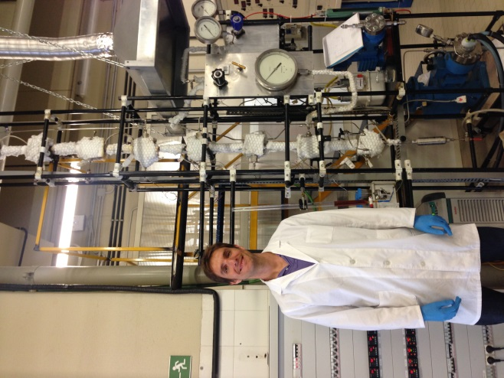
As the fractionation of those glycolipids had already been achieved in the aforementioned process, the driving force of this visit was to study the possibility of moving from a batch process to a continuous one using a counter current supercritical column. In this continuous process, the supercritical fluid enters the column from the bottom, while the mixture to be fractionated enters from the top. Varying the conditions in the column (pressure, temperature, contact time…) a more or less exhaustive fractionation takes place, collecting the heavier compounds at the bottom and the lighter ones at the top. The dimensions of the column are the following: 375 cm height and 1.75 cm internal diameter. A figure of this column can be seen in Figure 1.
Figure 1. Countercurrent column.

Outcomes - scientific
As a result of the scientific exchange, I was able to understand and master the technique of supercritical counter current fractionation. Maybe in the future this technique can be imported to the CO₂ lab to complete the versatility of our laboratories.
Regarding to the glycolipids purification, the final product obtained in this column showed a lower purity that in the batch process. More experiments would be needed to improve this purity, maybe in a further exchange. However, the fractionation achieved by this technique can be used as a pretreatment of the fermentation before conducting the batch process to increase the efficiency of it.
Outcomes – collaboration and going forward
Last but not least, as a result of this exchange, the networking between our group and the Italian one has been strengthened (see Figure 2). Two Erasmus plus stays next year have been set up, with two MEng coming over to our facilities, accounting for a total time of one year. This work will allow setting up a fruitful collaboration between research groups sharing valuable experiences within the supercritical fluid world

. 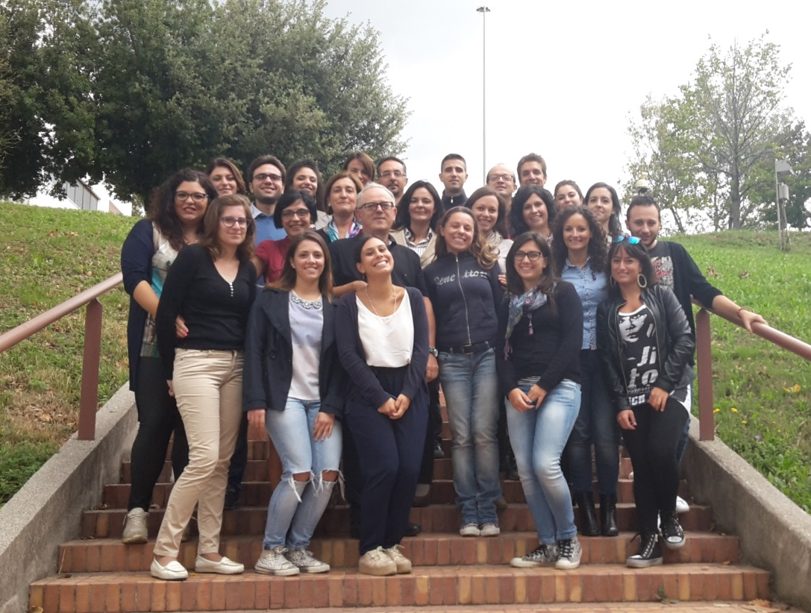
Figure 2. Supercritical fluids research group at Università degli Studi di Salerno.

